PAMANTASAN NG LUNGSOD NG MUNTINLUPA
COLLEGE OF TEACHER EDUCAION
NBP Reservation Poblacion, Muntinlupa City
Department of Preschool Education

PSED 106
Science, Health and Nature Study
(Life Science: Animals)

LESSON PLAN

The Pet Animals
Subject Matter

Nursery
Level

Pauline J. Anchorez
Name

PSED 2D
Year and Section

April 27, 2016
Date

Prof. Sannie A. Jusay

Content Focus: Explores what are the pet animals.
Meeting Time 1 | Teacher’s Activity | Student’s Activity
Opening Prayer  National Anthem  Today’s News  Days  Weather  Checking of Attendance  Motivation  Presentation of the Lesson  Message: Animals can be our friend.  Work Period  Teacher Supervised  Green Group  Objective:  To be able to know the pet animals.  Materials:  manila paper, pictures, tape  Procedures:  - Distribute the materials to the group.  - Pick the pictures of the pet animals and place it on the Manila paper.  Red Group  Objective:  To be able to know the pet animals.  Materials:  Manila Paper, pictures, marker  Procedures:  - Distribute the materials to the group.  - Check (√) it if it is a pet animal and cross (x) it if it not.  Yellow Group  Objective:  To be able to know the pet animals.  Materials:  Manila Paper, pictures, crayons  Procedure:  - Distribute the materials to the group.  - Color it blue if it is a pet animal and red if it is not.  Blue Group  Objective:  To be able to know the pet animals.  Materials:  Manila Paper, pictures, marker  Procedures:  - Distribute the materials to the group.  - Match the pictures of the pet animals to its name.  Recess  Meeting Time 2  Story  Ang Bata at ang Aso  Evaluation:  Name the pet that they have.  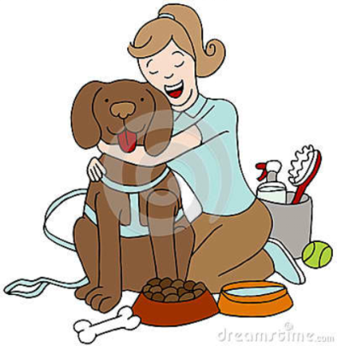  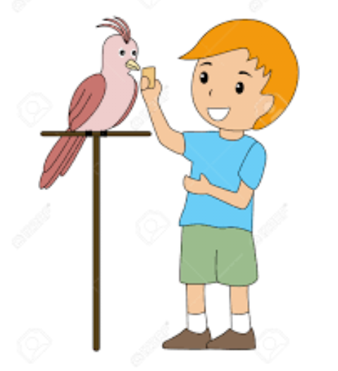  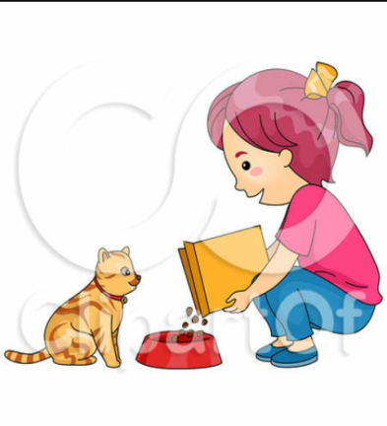  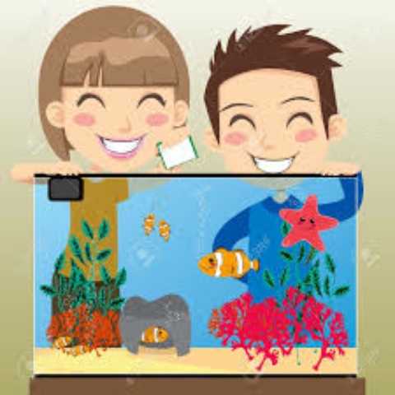  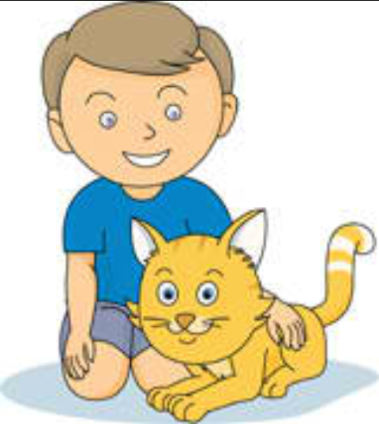  Indoor/Outdoor Activity  Objective:  To be able to know the characteristics of the pet animals.  Materials:  Manila paper, marker, crayons  Procedure:  - Group the pupils according to their row.  - Distribute the materials to each group.  - Each group will have an assign pet animal, and then they will going to write the characteristics of the given pet animal.  - In the lower part of the paper they will going to draw the pet animal that is assign to them.  Assignment:  Meting Time 3  Dismissal  Closing Prayer | “_____ please lead the Prayer”  “Children let’s sing our National Anthem.”  “_____ What is the day today?”  (The Teacher will ask the student to put the day on the chart)  “Class today is _____”  (The Teacher will ask the students to sing the weather song.)  “Class everybody look at the window and let’s see what is the weather today.”  “What is the weather today?”  (The teacher will sing the attendance song)  “How many boys are here today, here to learn, here to play?  How many boys are here today?  Let’s all count them!”  “Boys please stand”  “Boys count yourselves one by one”  “_____ will you please put the last number on the chart?”  “How many girls are here today, here to learn, here to play?  How many girls are here today?  Let’s all count them!”  “Girls please stand”  “Girls count yourselves one by one”  “_____ will you please put the last number on the chart?”  “Now let’s total the number of boys and the girls.”  “So your total number is _____”  “Children I have here a pictures, can you identify what are these?”  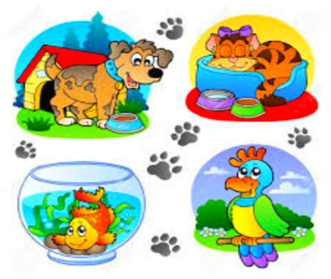  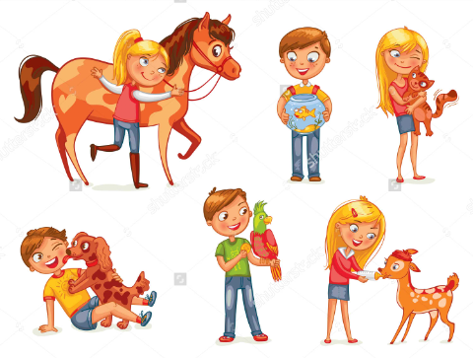  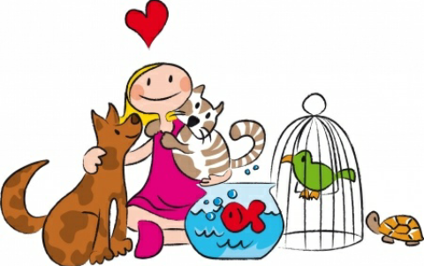  (The teacher will call one student)  “Yes _____ any answer?”  “very good _____”  “Any other answer?”  “Very good _____”  “Thank you children”  (The teacher will ask the pupils what did they saw in the picture)  “_____ what did you saw in the pictures?”  “Very good!”  “What else _____”  “Very good!”  “Give yourselves the Facebook clap!”  (The teacher will discuss the lesson.)  “There are animals that are taken cared of at home.”  “These animals are called pets.”  “These are the common animals that can be our pet: Fishes, Birds, Cats, Dogs, Rabbits, some has Ducks, Roosters and Turkey.”  “These are the pictures of some of them.”  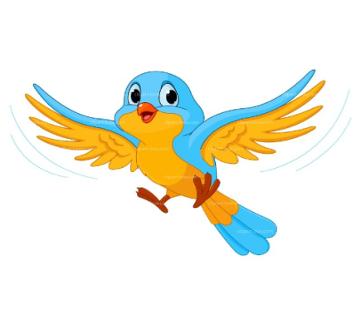  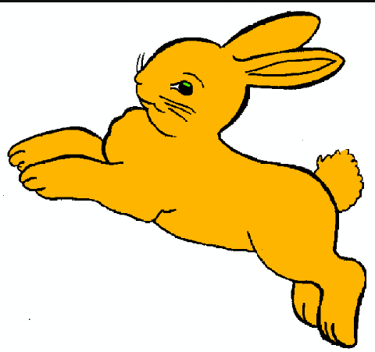  “Animals can our friend and can be part of our family.”  “Did you understand class?”  “Children I will give you an activity but before you start listen first to the standards during your group work.”  (The teacher will read the standards during the group work)  (The teacher will explain the rubrics in group activity)  (The teacher will group the class into Four groups - Green Group, Red Group, Yellow Group, Blue Group)  (The teacher will give the group activity and the directions to each group)  (The teacher will announce the group who follow the standards. The teacher will give ribbons to the group who followed all the standards.)  (The teacher will ask the pupils to prepare their foods and pray first before they eat.)  “_____ will you please lead the prayer?”  (The teacher will sit on the chair and sing “kwentuhan na!” tune of Bukas na Aklat, Batang Mulat)  “Kwentuhan na, kwentuhan na.  Magkwentuhan na at magsaya.  Kwentuhan na, kwentuhan na.  Magkwentuhan na at magsaya.”  (The teacher will show the standards during the story time)  “My story for today is entitled Ang Bata at ang Aso.”  “Are you ready to listen children?”  “Si Boyet ay may alagang aso. Ang tawag niya dito ay Tagpi. Puting-puti ang makapal na balahibo ni Tagpi. Sa bandang likod ay mayroon itong isang malaking tagpi na kulay itim. Iyon ang dahilan kung bakit Tagpi ang itinawag ni Boyet sa kanyang aso. Mahal na mahal niya si Tagpi. Palagi niya itong pinaliliguan. Binibgyan niya ito ng maraming masasarap na pagkain at tubig. Madalas din niya itong ipinapasyal.  “Habol, Tagpi!” Sigaw niya habang nakikipag-unahan siya sa pagtakbo sa alaga.  Isang araw ay may naligaw na aso sa lugar nina Boyet. Kasing laki ni Tagpi ang aso pero kulay tsokolateito. Manipis ang balahibo ng tsokolateng aso kaya hindi ito magandang tingnan. Marami pang putik sa katawankaya mukha rin itong mabaho. Hindi ito tulad ni Tagpi na ubod ng linis dahil araw-araw niyang pinaliliguan.  Nakita ng tokolateng aso si Tagpi. Lumapit ito sa bakod nila at tinahulan ang kanyang alaga. Ginalawgalaw pa ang buntot ni Tagpi na parang tuwang-tuwa.  Hindi nagustuhan ni Boyet namakikipaglaro si Tagpi sa marungis na aso. Binugaw niya nag aso pero ayaw nitong umalis.  “Tsuu, tsuu!” Bulyaw niya dito.  Ayaw umalis ng aso, panay ang tahol nito kay Tagpi. Nainis si Boyet. Kumuha siya ng mahabang patpat at hinampas niya ang aso. Nabuwal ito at nag-iiyak.  Hahampasin sana muli ni Boyet ang kulay tsokolateng aso para tuluyan nang umalis pero dumating ang kanyang tatay, agad siyang inawat nito.  “Huwag mong saktan ang aso, Boyet!” sabi ng kanyang ama.  “Ang baho po kasi, itay. Baka mamaya ay mahawa pa sa kanya si Tagpi”. Katwiran niya.  “Paano kung si Tagpi ang mapunta sa ibang lugar at saktan din siya ng mga bata doon. Magugustuhan mo ba iyon?” Tanong ng ama.  Hindi nakasagot si Boyet. Napahiya siya.  Tinulungan nilang makatayo ang aso. Pinabayaan na niya itiong makipaglaro kay Tagpi.”  “Did you like my story?”  “Who are the two main characters in the story?”  “What pet did Boyet have?”  “At the end of the story what did Boyet do?”  “What lesson did you learn in the story?”  “Very good children!”  “Give yourselves a achieve clap”  (The teacher will explain the procedure of the game to the pupils)  (The teacher will give ribbon to the group who will win.)  Draw the pet animal that you have or you want to have in the short bond paper, and color it.  “Children get your things and stand on the line. Let us sing our goodbye song. Tune of Old McDonald had a farm”  “_____ will you please lead the prayer?”  “Goodbye Children!” | (_____ will lead the Prayer)  “Panginoon salamat po sa panibagong araw na ito, salamat po sa mga biyaya na inyong ibinigay sa amin. Patawad po sa aming mga pagkakasala at mga pagkukulang. Hinihiling po naming na gabayan nyo po kami sa araw na ito at maging makahulugan ang aming araw at magiging talakayan. Maraming salamat po. Amen.”  (The pupils will put their hand in their left chest and sing the National Anthem)  Bayang magiliw,  Perlas ng Silanganan,  Alab ng puso,  Sa dibdib mo’y buhay  Lupang hinirang,  Duyan ka ng magiliw,  Sa manlulupig,  Di’ ka pasisiil  Sa dagat at bundok,  Sa simoy at sa langit mong bughaw,  May dilag ang tula at awit sa paglayang minamahal  Ang kislap ng watawat mo’y tagumpay na nagniningning,  Ang bituin at araw niya kailan pa may di’ magdidilim  Lupa ng araw ng luwalhati’t pagsinta,  Buhay ay langit sa piling mo,  Aming ligaya na pag may mangaapi,  Ang mamatay ng dahil sayo.  (The student will tell the day today)  (The student will put the day on the chart)  “Today is _____”  (The student will tell the date today)  (The student will put the day on the chart)  “Today is _____”  (Pupils will sing the “Weather song” while looking at the window)  Sunny, sunny, sunny, sunny.  It is sunny in the sky.  S-U-N-N-Y sunny,  It is sunny in the sky.  Rainy, rainy, rainy, rainy,  It is rainy in the sky.  R-A-I-N-Y rainy,  It is rainy in the sky.  Windy, windy, windy, windy.  It is windy n the sky.  W-I-N-D-Y windy,  It is windy in the sky.  Stormy, stormy, stormy, stormy,  It is stormy in the sky.  S-T-O-R-M-Y stormy,  It is stormy in the sky.  “Today is _____”  (The boys will count themselves one by one)  (the last boy that count will put the last number on the chart)  (The girls will count themselves one by one)  (the last girl that count will put the last number on the chart)  (The pupils will look at the pictures)  (_____ will stand and tell his answer)  “Teacher they are playing with the animals.”  “Teacher they love the animals.”  “Teacher we saw animals.”  “We saw kids playing with them.”  (3 claps, 3 stamp feet, shout like, like, share!)  (The pupils will listen attentively)  “Yes we did!”  (The pupils will listen carefully)  (The group leader will come in front to get the activity, the group will listen to the given direction carefully)  (_____ will lead the prayer.)  “Panginoon salamat po sa araw na ito, at sa pagkain po na nasa aming harapan ngayon. Salamat po sa lahat. Amen.”  (The pupils will sing with her)  (The children will read the standards)  Standards:  - Seat properly.  - Attention on the story.  - Understand the story.  “Yes we are!”  “Yes we are!”  “Boyet and Tagpi”  “He has a dog.”  “He let Tagpi play with the dirty dog.”  “Don’t hurt the animals just because they are dirty and not smelling good because they are has a feelings”  (3 claps, 3 stamp feet, shout achieve!)  (The children will copy the assignment in their assignment notebook)  (The children will get their things and stand on the line will singing the song)  “Goodbye, goodbye, goodbye teacher.  See you tomorrow.  Goodbye, goodbye, goodbye classmates.  See you tomorrow.  We’ve learn today, we’ve play today.  Take care for all of us.”  (_____ will lead the prayer)  “Panginoon salamat po sa araw na ito. Sa mga aral na aming natutunan mula sa aming guro. Gabayan nyo po ang bawat isa sa amin. Amen. ”  “Goodbye Teacher Pauline, Goodbye classmates, see you all tomorrow. Mabuhay!”

